**DR1 Draft**

**Introduction**

Aim of the project is to build an electronic buggy, which can autonomously follow a white line around a track, which consists of sharp turns and a slope (that has an angle of less than 18 degrees). For our buggy to go up the ramp it will require more torque, therefore we need something which will change the torque and speed of the buggy, depending on the situation, e.g. moving up the ramp or on a flat surface. To achieve this our buggy requires a gearbox.

**Using a gearbox has advantages but also some disadvantages:**

Advantages

* It can change the torque, depending on the load, on the motor.
* It can be used to increase and reduce the speed.
* Provides large variety of torque and speed with same input power.

Disadvantages:

* Results in lower overall efficiency due to additional components. E.g. energy lost due to friction between gear wheels.
* Additional cost of a gearbox.
* Maintenance of the gearbox. E.g. lubricating the teeth, for better functionality.

We have three options of gearboxes to choose from, and to choose the best gearbox for our buggy we have done various experiments and calculation, which are discussed later in the report.

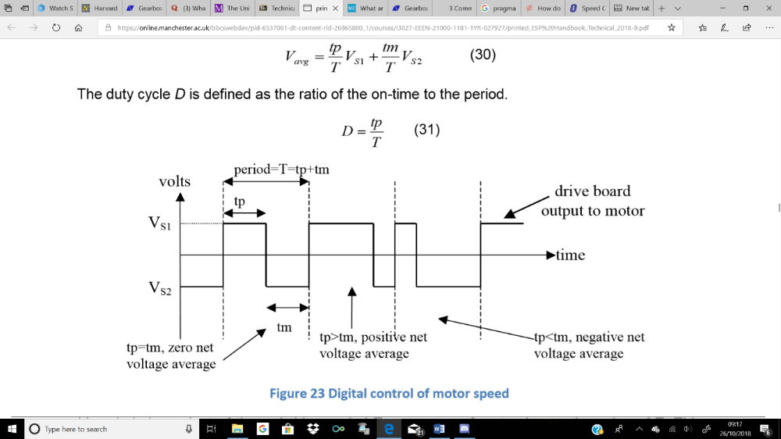The buggy uses DC motors, which are controlled by changing the voltage applied to the terminals. The most efficient way of powering the motor is using digital switches, which are used to produce analogue voltage output. This is done using motor drive board. An example output from the motor drive voltage waveform is shown below.

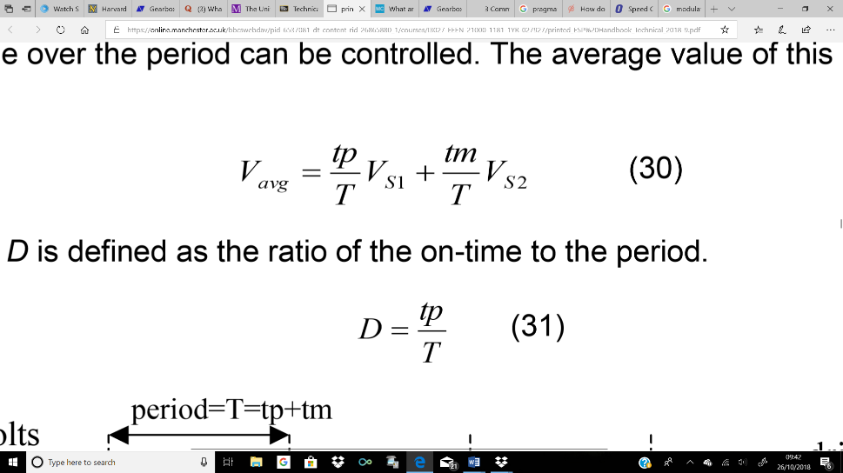

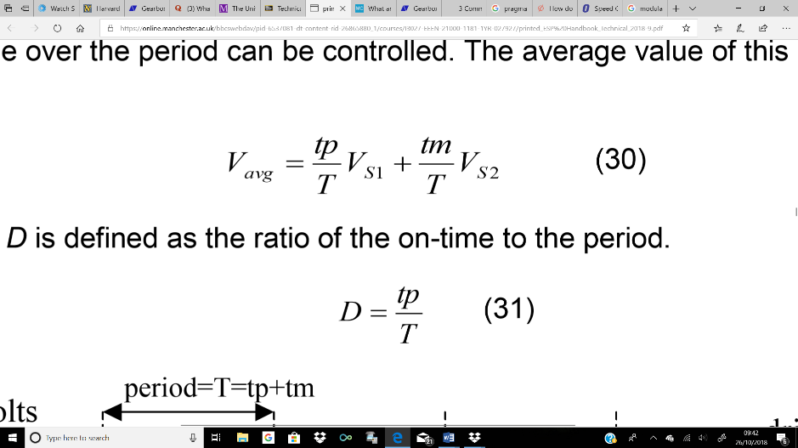

If the voltage is switched between VS1 and VS2, and the ratio of on-time (time in higher voltage state, tp) to period (tp+tm) is modified, average voltage over the period can be controlled by changing the on-time. Voltage average of this pulse is given by equation (1) and the ratio of on-time to period (Duty cycle D) is given by equation (2).

Motor drive board has switches arranged in a “H” pattern and bipolar and unipolar are two ways in which H-bridge switch pattern operate. In bipolar mode all 4 switches are used and there is constant switching between the full battery voltage in one direction and full battery voltage in the other. In unipolar 2 switches are changing states between battery voltage and 0V.

Microcontroller is used to control the motor drive board. PWM signals (Pulse width modulation) are sent to the motor drive board by microcontroller to control the speed of motor. It also sends a digital signal, to motor drive board, to select bridge control mode (bipolar, unipolar), and if unipolar, then the direction of movement is sent, using another digital output pin.

**Motor characterisation**

The motor needed for build our buggy should not exceed some limitations:

The maximum voltage that will be provided to the motor will be approximately between 3 and 5 volts. The final circuit will send a signal to the motor within this range and the power supply need to send enough power to feed not only the 2 motors but also all the electronic elements of the buggy. In addition, the current must be enough to overcome the stall position of the buggy and go up through the ramp on the race day. However, the maximum current demand needs to fit with the provided one by the circuit and if it is too high a big drop of voltage will occur in the leads. It is necessary to find a balance between the current need for make our buggy to move and go through the ramp and all the current that the batteries can supply. Batteries running out in the middle of the race will not be acceptable.

To calculate the armature resistance, the motor was stalled, applying a start voltage of 1 volt and a protection current limit of 1.7 amps, measurements were taken increasing each time 0.25 V until the current limit is reached. Using the formula from the technical handbook, equation 9, page 24:

$$V=K_{E}ω+IR+V_{b} \left(Eqn. ??\right) I=\frac{V-V_{b}}{R}-\frac{K_{E}ω}{R}$$

Where $K_{E}ω=0$, i.e. motor is stalled;

$I=\frac{V-V_{b}}{R} (Eqn.??)$

Graph??

Armature Resistance=2.42Ω

Graph??

Graph??

**Load measurements:**

**How does this section relate to the rest of the report?:**

The aim of the experiment is to know the required force and hence the torque to move the buggy from stationary and at constant speed through both stages of flat surface and ramp in the examination. By completing the load experiment and using the results to calculate the static and rolling friction coefficient, the force to move any buggy mass can be calculated, hence the torque. Once the torque is known;

**Current and voltage:**

The current and power supply voltage required to move buggy can be calculated; **see mathematical relationship 4.1 in Gear ratio section.**

**Required Gear ratio:**

The Gear ratio can be selected as the selection is based on the compromise of both providing enough torque at the wheels for buggy to move through greatest resistance and still have significant speed. Here greatest resistance would be going from stationary to moving on ramp. **See mathematical relationship (4.4) of torque between motor and wheel in gear ratio section.**

**Estimated Force to drive buggy up the slope and across flat:**

**Estimated Forces: flat**

**Equation 1: $F=m.g.C_{p}$ (2.1) $C_{p}=coeffient of friction, m=mass \left(kg\right), g= gravitational constant \left(m.s^{-2}\right)$**

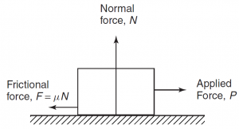

On the flat, assuming air resistance is negligible, the only frictional force is the surface the buggy is on given by figure ??. Using the average rolling of ramp and static coefficient friction of flat, again assuming the estimated mass is 1250 grams, the forces are:

|  |  |  |
| --- | --- | --- |
| On flat (second run) | Friction coefficient | Force (N) |
| Static | 0.064 | 0.785 |
| Rolling | 0.057 | 0.699 |

**Justification for accuracy of results:**

These results show accuracy as theory agrees with that static friction coefficient should be greater than the rolling coefficient exhibited by the gradient of figure ??. By comparison to 4 other groups that got static coefficient in the range of 0.070 – 0.060 and rolling coefficient 0.060 – 0.050, the results seem valid. Finally, the fact the standard error associated with results is low due to measurement for 5 different weights; static = +-0.332% and rolling = +-0.363%.

**Estimated forces: slopes**

**Equation: $F=C_{p}.m.g.\cos{θ }+m.g.\sin{θ}$ (2.2); $C_{p}=coeffient of friction, m=mass \left(kg\right), g= gravitational constant \left(m.s^{-2}\right), θ=theta (degrees)$**

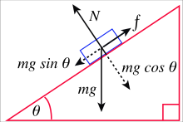

This equation is described by the mechanics of forces on a ramp shown in **figure ??**. Weight, m.g, is now involved as it is at angle.

Using the average rolling of ramp and static coefficient friction of flat, again assuming the estimated mass is 1250 grams, and using angle measured 15.5 degrees, the forces are:

|  |  |  |
| --- | --- | --- |
| On ramp (second run) | Friction coefficient | Force (N) |
| Static | 0.140 | 4.93 |
| Rolling | 0.059 | 3.97 |
| Chosen static | 0.0768 | 4.18 |
| Chosen rolling | 0.0684 | 4.09 |

**Justification of accuracy of results:**

The results of the first run of ramp experiment on slope will be ignored due to incorrect experimental measurement procedure.Since the measurement of friction coefficient on the ramp is generally inaccurate as 0.14 has a too large a difference from 0.0768, the flat friction coefficient of static and rolling will be used but with the addition of 20 %. This is done because in ramp friction as even though in theory the flat and ramp coefficient of friction should be the same, the ramp has different variables in place hence the flat surface coefficient of friction will be used at a compromise.

**Required torque: flat and slopes**

**Equation 3: $T=F.r$ (2.3), $T = Torque (Nm), F = Force (N), r = radius (m)$**

Torque at a perimeter of circle is described by above relationship.

The required torque is now just a matter of using the relationship between the radius of the wheel and the force required;

**Required torque for each stage:**

Using equation 2.3, the measured diameter of the wheel; 8cm and angle of slope 15.5 degrees;

Moving from each motor for motion on flat bench surface; stationary to moving = 0.0314 Nm, at constant speed = 0.0280 Nm.

Moving from each motor for motion on slope bench surface; stationary to moving = 0.1672 Nm, at constant speed = 0.1636 Nm. These are all calculated assuming the efficiency of the gearbox is 100% and thus aren’t the final torque we are planning to use. This should be calculated in the gear box selection section.

**Gear ratio selection**

One of the primary aims of the project is to allow the buggy move at the highest possible speed and simultaneously move up the highest incline available. As both speed and torque are inversely proportional, a mechanism is needed to balance this relationship in the most effective way. This mechanism is applied using a gearbox in which a connection is achieved between the electric motors and the buggy wheels. This linkage allows the output shaft operate at a lower speed than the input shaft. This compensation gives a mechanical benefit in terms of an increased torque at the output shaft. This allows the buggy to face no problems in climbing the maximum incline.

To illustrate the importance of the gearbox, an assumption is made that the given motors will solely drive the buggy, with no gearbox. As stated in section ???, the required wheel torque to go up the maximum incline is ${ T}_{3}= 0.183 Nm$. From the Torque-Current relationship in figure ???, the torque could be inserted in the equation:

$T=0.008I-0.0009 (4.1)$ giving a calculated current of $I=\frac{0.183 + 0.0009}{0.008}=22.99 A$.

Now, using the Voltage-Current relationship in figure ???, the required motor voltage:

$$V=2.4211×22.99+0.1568=55.81 V (4.2)$$

These values reveal the required current and voltage to move the buggy up the ramp using just the motors, which explains the necessity of the gearbox which certainly reduces these current/voltage values into much convenient numbers.

**Required gear ratio**

Referring to figure ???, the maximum available torque produced by the motor is T = 0.01 Nm at constant motor voltage of V = 5 V. This value is available at the maximum permissible current of 1.4 A. However, to avoid any risks, a safety margin is taken to assume no operation occurs at 1.4 A. Instead, the available motor torque is assumed to be at 1.23 A and so by reading the graph in figure ???, this gives a motor torque of $T_{1}=0.009 Nm$.

As before, required wheel torque is ${ T}_{3}= 0.183 Nm$. As a result, the gear ratio formula could be used: $atio= \frac{T_{3}}{T_{1}} (4.3)$. Using (4.3), required gear ratio is $io= \frac{0.183}{0.009}=20.3$.

**Chosen gearbox**

The design of the available gearboxes compromises of two gear stages, each with an efficiency of 85% giving an overall estimated efficiency of $η={0.85}^{2}=0.7725.$ Four gear wheels form the whole system including gear wheel 1 on the input shaft, gear wheels 2A and 2B both on the common shaft and gear wheel 3 on the output shaft. Figure ??? illustrates this, accompanied with the gear ratio formula.

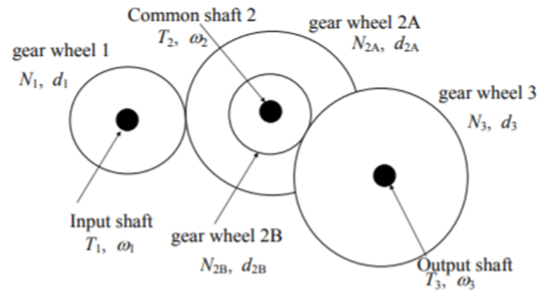

$$\frac{T_{3}}{T_{1}}= η\frac{N_{3}N_{2A}}{N_{2B}N_{1}} (4.4)$$

Figure ??? Common gear wheels on one shaft [1]

The following table, table ???, compares the 3 different gearbox options available, alongside their respective calculated gear ratios, taking into account the efficiency.

Table ??? Gear ratio comparison

|  |  |  |  |  |  |
| --- | --- | --- | --- | --- | --- |
| Option no. | $$N_{1}$$ | $$N_{2A}$$ | $$N_{2B}$$ | $$N_{3}$$ | Gear ratio using (4.4) |
| 1 | 16 | 48 | 12 | 48 | $$0.7725×\frac{48×48}{12×16}= 9.27$$ |
| 2 | 16 | 50 | 10 | 48 | $$0.7725×\frac{48×50}{10×16}= 10.84$$ |
| 3 | 16 | 50 | 10 | 60 | $$0.7725×\frac{60×50}{10×16}= 13.55$$ |

Consequently, gearbox 3 is the chosen option due its gear ratio being the nearest to the required gear ratio, calculated above.

**Intermediate shaft position**

To achieve the required intermediate shaft position, the Pitch Circle Diameter (PCD) needs to be calculated, using the following formula: $PCD=no. of teeth ×MOD \left(4.5\right).$ In this case all gears are 0.5 mm module. For gearbox 3, using (4.5), PCD(1) = 8 and PCD(2A) = 25.

Furthermore, the x-coordinate of the center of the intermediate shaft, with respect to gear wheel 1 center, is calculated using the formula

$x=\frac{PCD\left(1\right)+PCD\left(2A\right)}{2}+0.1 mm= \frac{8 + 25}{2}+0.1= 16.6 mm$

**Maximum speed**

From figure ??? above, at 1.23 A, the motor speed is measured to be $ω_{1}= 2221 rpm.$ Using the following torque-speed relationship $ω_{3}= \frac{ω_{1}×T_{1}}{T_{3}} \left(4.6\right)$, the maximum speed calculated is $ω_{3}= \frac{2221 ×0.009}{0.183}=109.23 rpm.$